**Name:** Ilgaz Mehmetoğlu  
**Student Number:** i6385148



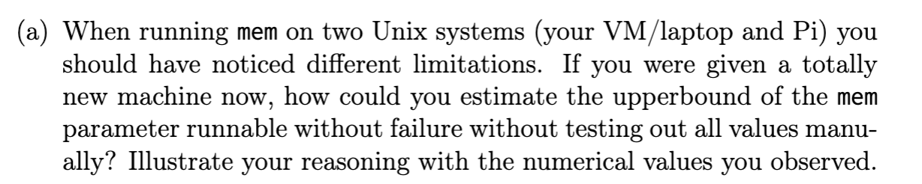

I did a bit of research as I was in the lab about what actually limits *./mem N* on the two environments I tested it on. Brute forcing is one way to find an upper limit of course, but it is a bit impractical and based on the overcommit mode the Linux kernel is currently in. I could just run *htop* to see how much physical memory.

***Running htop on the Raspberry Pi***  
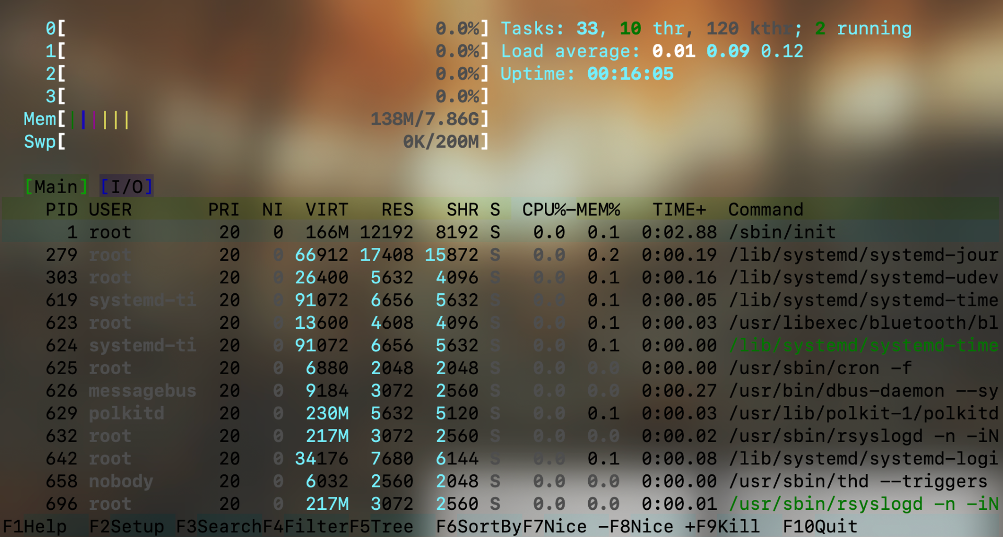

In this case we see that we have 8 gigabytes of physical memory and 200 megabytes big of a *swap partition* on the disk. To estimate an upper bound by brute forcing I could do something like *./mem 8000* which would push it to the physical memory limits.

***Running mem.c with parameter 8192***

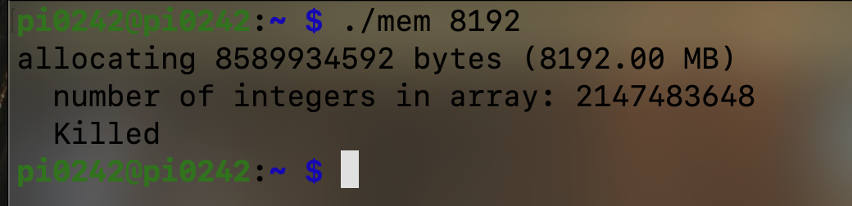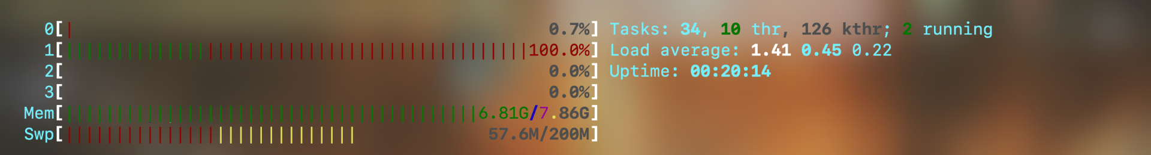

However, a more robust way to do it is by grepping the appropriate information. For instance we can run the following: *grep -E 'MemTotal|MemAvailable|SwapTotal|SwapFree|CommitLimit|Committed_AS'C/proc/meminfo*

***Results of the grep command***

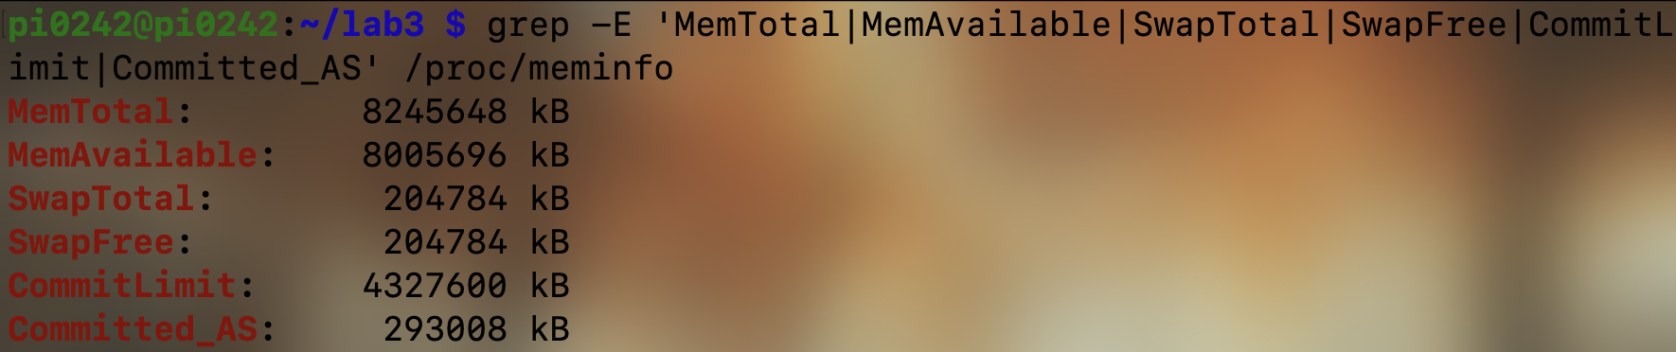

This gives us a bit more information. On the Raspberry Pi, we can see that the total available memory is about 8 gigabytes, the available memory is a few megabytes less than that, and we can also see the when idle we’re not touching the swap space at all.   
  
The two important fields to pay attention to here are **CommitLimit** and **Committed_AS.** These are commit accounting fields Linux uses. We know that **malloc is refused immediately** once the promised memory would exceed what the kernel allows, which is *Committed_AS + request > CommitLimit.*

After researching a bit online, the formula for a conservative bound becomes:

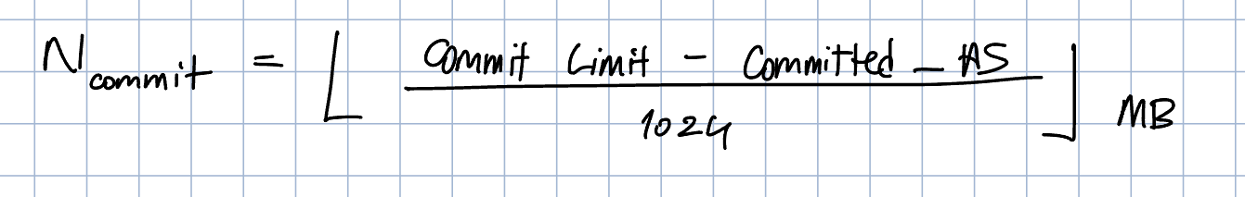

So, we can calculate the strict commit bound on the Pi (applicable to any other Linux machine):

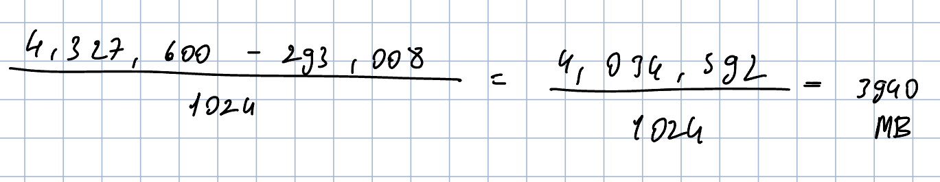

So the conservative upper bound for the Pi appears to be 3940 megabytes. Before we can test this value and infer anything meaningful, I want to first explain overcommit modes in the Linux kernel.

There are three overcommit modes that the Linux kernel adheres to.   
  
The default is when vm.overcommit_memory = 0 and the kernel uses a risk estimate and may allow allocations **even if** Committed_AS + request > CommitLimit. So, setting it to 0 is not a hard gate.

Setting it to 1 is basically the “always overcommit” mode. Failures happen later if/when the process actually touches more memory than the machine can back.

Setting it equal to 2 engages the no overcommit behavior. The kernel **enforces** the accounting: allocation is refused exactly when Committed_AS + request > CommitLimit.

***Setting the overcommit mode to 2***  
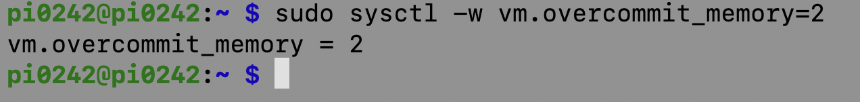

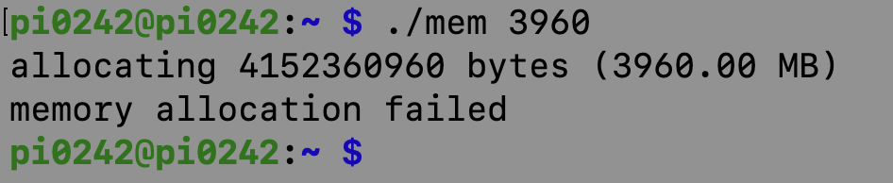

If we try to allocate even 20 more megabytes, it fails. When seemingly we have 8 gigabytes of free physical memory.   
  
***A situation when the overcommit mode is set to 1***

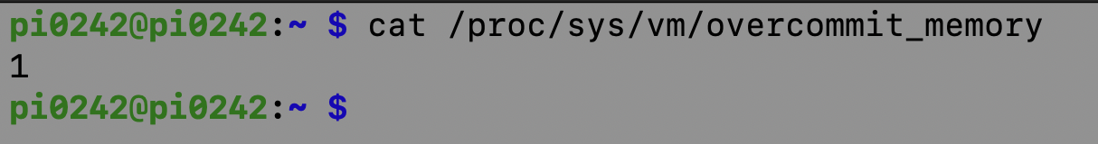

***Allocating more memory than the physical memory in mode 1***

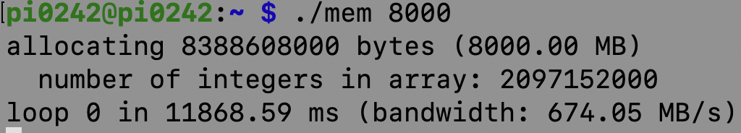

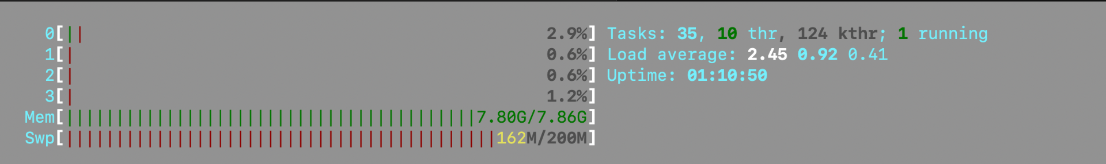

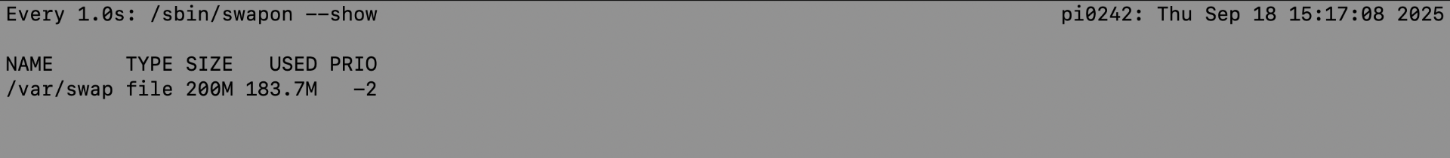

In the overcommit 1 mode, as we can see, with the physical memory fully being used up and only around less than *~20 megabytes* of swap remaining, it still keeps going.

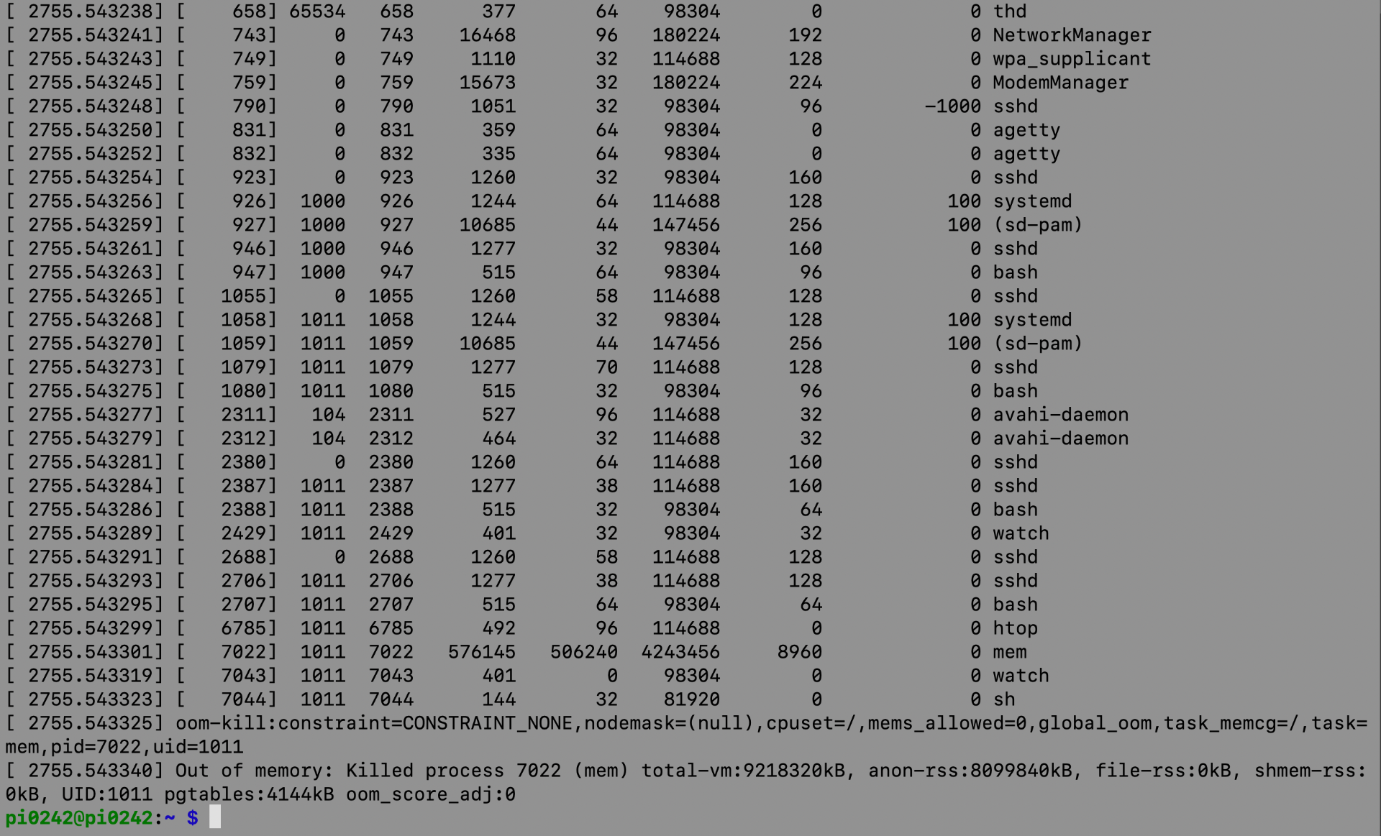

It is only killed when the process touches more memory than the hardware can support.   
  
So, in conclusion, I would first check what the overcommit mode is set to, grep the necessary information from */proc/meminfo* and decide what to do from there. If it’s in mode 1, it can allocate as much as it’s limit’s allow, so we can just combine the physical memory and the swap partition. If it’s in mode 2 (which is the conservative mode) we apply the formula accordingly.

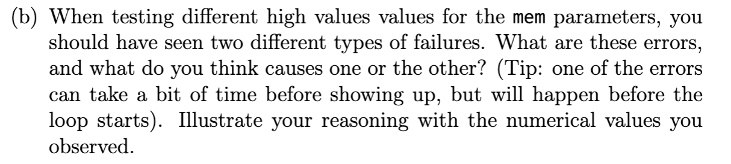

From */proc/meminfo* alone we can answer this question, and using vmstat as it was suggested in the lab manual at first. There are two distinct failure points for *./mem N*.  
  
The first is an immediate allocation failure (before any loop can actually run) the kernel refuses it when *Committed_AS + request > CommitLimit.* This is enforced exactly in overcommit mode 2.   
  
To switch things up and see if our my findings actually carry out between boxes, I’ll use a Debian virtual machine to test it out.   
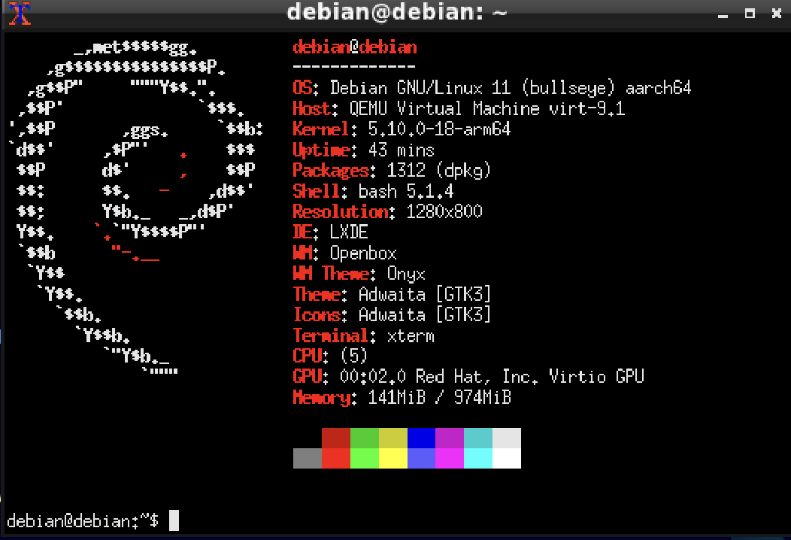

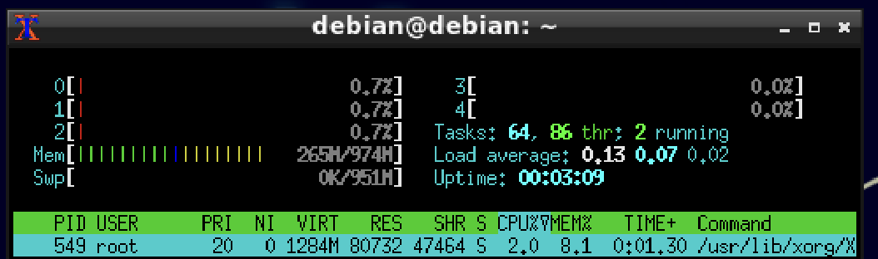

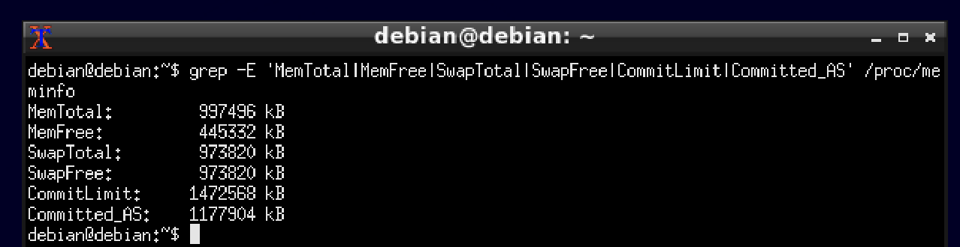

Let’s also check which overcommit mode we’re in.

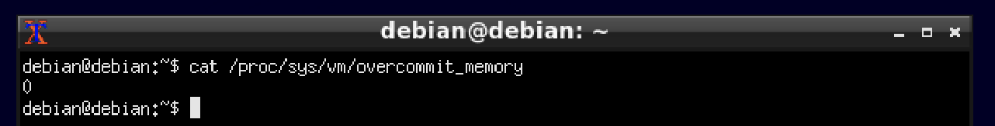

We’re currenly in mode 0. To observe the immediate allocation failure, let’s go into mode 2 (strict):  
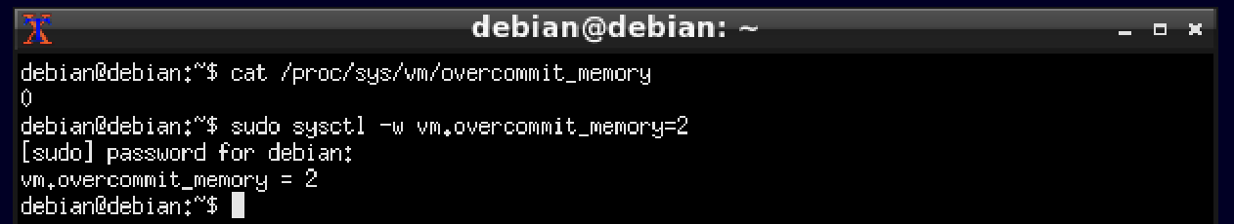

Let’s now do the same calculation for the strict upper bound memory just as we did for the Pi.

Floor((1,472,568 - 1,177,904) / 1024)= 287  
  
So, in mode 2, 287 megabytes should be the largest amount that should be accepted. 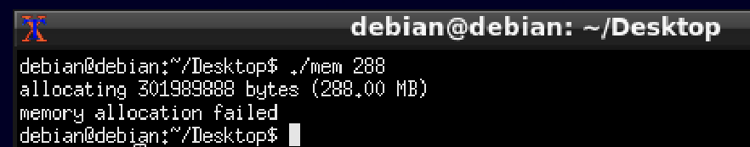

Indeed, even a megabyte above that fails.   
  
The second type of failure is a OOM kill after allocation. This happens if the kernel is in heuristic (0) or overcommit (1) mode where malloc() can be granted even when the request is larger than what the machine we have can actually physically support. This type of crash happens later when the program touches those pages and the kernel can’t find RAM or swap back to them.   
  
In this case, we can estimate our “backable now” memory simply as *MemAvailable + SwapFree.*

***Putting the kernel in overcommit mode 1***

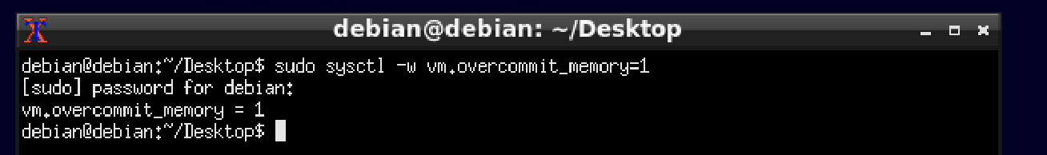

***Grepping available physical memory and swap sizes***

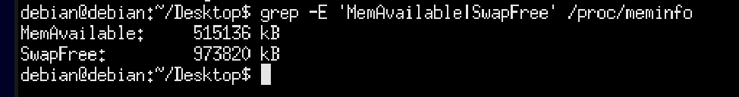

The backable now memory is around 1454 megabytes.

***Before stressing the memory (idle)***

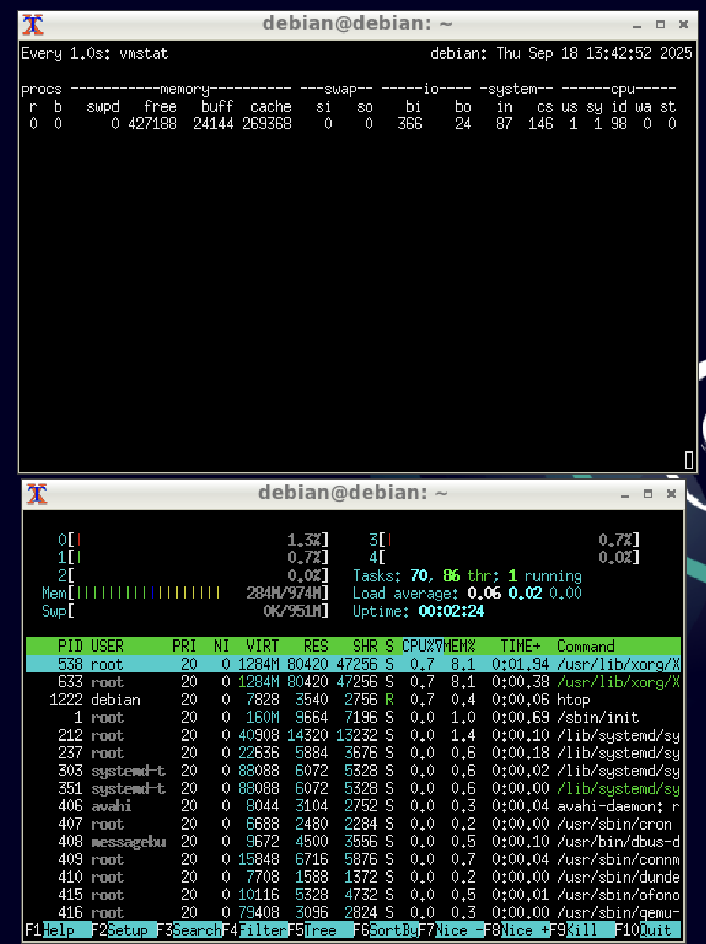

Let’s pick an N > 1454 MB and stress it. Something like 1550 should be enough.

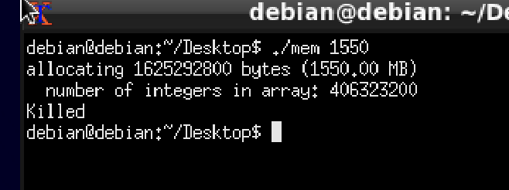

We see that malloc() actually succeeds. The program begins it’s first pass. Before the first loop prints though, the process is killed. In the screenshot below we can look at the free column and how it’s drastically reduced, and how the swpd colum has skyrocketed even if it runs for an instant.

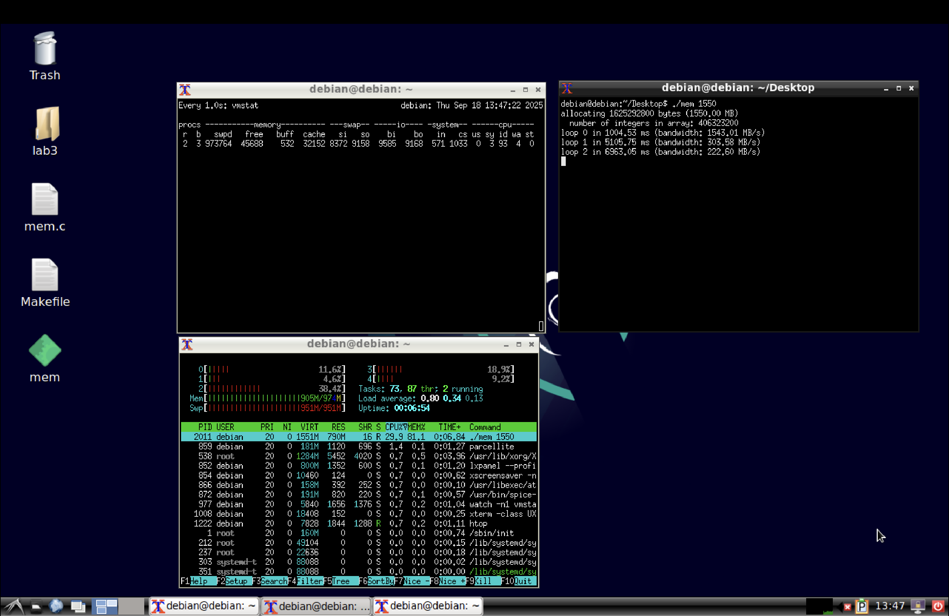

We can further verify that this actually happened using journalctl.

***A screenshot from journalctl***

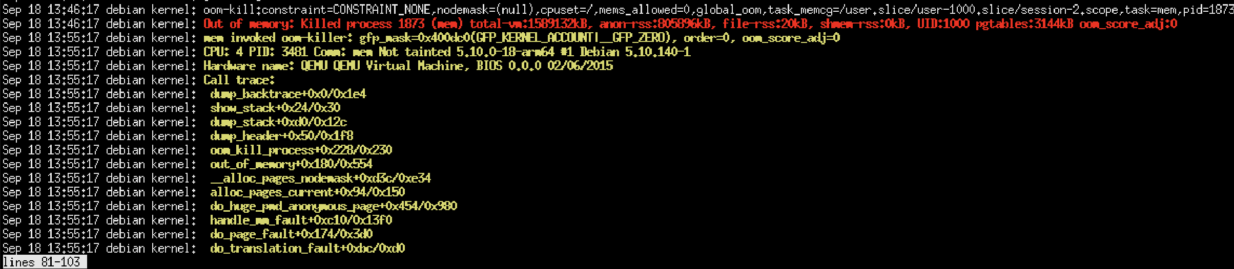

Looking at the entries, we can indeed see the out of memory error and that it was an OOM kill.   
  
As a verdict, there are two types of memory failures, one that happens before any loop which is an immediate allocation failure, which is only observable on the strict overcommit mode. The other one is observable on mode 1/2 and malloc() is granted, but the kernel’s OOM killer kills the process after a loop.